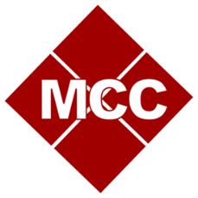

Martin Community College
Administrative and Student Support Units
Annual Institutional Effectiveness Plan

Area/Department Name: Click here to enter text.

Academic Year: Click here to enter text.

Date of Initial Submission: Click here to enter text. Submitted by: Click here to enter text.

Date of Final Submission: Click here to enter text. Submitted by: Click here to enter text.

Administrative/Student Support Unit Mission:
Click here to enter text.

Unit Outcomes
Unit outcomes are general statements of what a unit or program intends to do, achieve, or
accomplish through certain activities or experiences. Academic and student support units may also include student learning outcomes, statements of what students should know, think, or do as a result of an intervention by that specific department.

Unit/Student Learning Outcome #1
Strategic Objective | Choose an item.
Actions to Achieve Outcome
Method of Assessment/Rationale
Criteria for Success/Rationale
Results
New action plan based on results.
Evaluation of previous cycle’s action plans.
Unit/Student Learning Outcome #2
Strategic Objective | Choose an item.
Actions to Achieve Outcome
Method of Assessment/Rationale
Criteria for Success/Rationale
Results
New action plan based on results.
Evaluation of previous cycle’s action plans.
Unit/Student Learning Outcome #3
Strategic Objective | Choose an item.
Actions to Achieve Outcome
Method of Assessment/Rationale
Criteria for Success/Rationale
Results
New action plan based on results.
Evaluation of previous cycle’s action plans.

Initial Submission Reviewed by: Click here to enter text. Date: Click here to enter text.

Final Submission Reviewed by: Click here to enter text. Date: Click here to enter text.

